Small Business Committee
Subcommittee on Innovation, Entrepreneurship, and Workforce Development
Subcommittee Hearing – January 17, 2024, at 10 am – Rayburn 2360
Pathways to Success: Supporting Entrepreneurs and Employees with Disabilities

Keith Wargo – President and CEO, Autism Speaks
Thank you, Chairman Molinaro, Ranking Member McGarvey, Chairman Williams and all Members of the Committee for hosting this hearing and for inviting me to testify on this critical issue.
I am Keith Wargo, President and CEO of Autism Speaks, a national, non-profit organization dedicated to creating an inclusive world for people with autism throughout their lifespan. We do this through advocacy, services, supports, research, and advances in care. As an organization, we are particularly proud of our work to develop and scale innovative solutions to help ensure that more autistic people can secure meaningful employment.
Alongside my role as President and CEO of Autism Speaks, I am also here as a father. My wife, Anne, and I are the proud parents of two, including our autistic son AJ. We've observed AJ's employment journey, witnessing challenges and triumphs. Prior to joining Autism Speaks, I spent nearly three decades in the private sector, including as an owner of Monarch Towel Company, a hospitality amenity supplier based in New Jersey that has made it a mission to employ autistic people. These experiences have cemented my belief in the necessity and potential of inclusive employment for the neurodiverse and other individuals with disabilities, which can be a key driver of economic growth across our nation.
Despite strides in autism and disability awareness and acceptance, we still face significant challenges in inclusive employment. In 2022, only 21% of people with disabilities, including autism, were employed. This data underscores a persistent gap in the job market. Further, over half of young adults with autism face unemployment or are not enrolled in higher education in the two years after high school, which is a higher rate compared to their peers with other disabilities. These statistics highlight the ongoing need for targeted employment support and opportunities in this community.
However, many individuals with disabilities have the skills and desire to work, and hiring neurodiverse people benefits the companies they work for, and the overall economy.
A recent study showed that companies that actively seek to employ people with disabilities outperform businesses that do not. Their revenues, net income and profit margins were all higher. At the national level, this analysis revealed that the U.S. GDP could get a boost of up to $25 billion if more people with disabilities joined the labor force.
Beyond the numbers, there are many additional benefits that accrue to individual workplaces and our society when employers embrace inclusivity. These include increased creativity and innovation in the workplace, diminished stereotypes, and reduced social stigma and discrimination.
What I have learned through my personal experience with both my son and with Monarch, as well as through our work at Autism Speaks, is that small, but meaningful steps taken by employers can make a significant difference. This can include changing hiring practices to consider alternative processes to interviews, which can often be a barrier for many talented autistic job seekers. It can include providing training courses to foster acceptance of neurodiverse individuals in the workplace. And it can include making minor changes to create more adaptable workplaces through flexible schedules or making accommodations for sensory needs.
One initiative I wanted to focus on today is our Workplace Inclusion Now program, or as we call it – WIN. WIN is an evidence-based workforce development program promoting diversity in hiring and helping create an inclusive workplace culture in which not just autistic adults, but all employees, can thrive. The WIN model is based on an ecosystem of three pillars (1) employers committed to creating inclusive workplaces; (2) autistic job seekers who are empowered with the tools they need to succeed and (3) communities supported with resources that promote inclusive hiring.
Our WIN model offers a scalable solution for diverse industries nationwide. Collaborating with Virginia Commonwealth University's Autism Center for Education, we've created online courses accessible nationally. These courses, emphasizing support for higher-needs individuals, raise awareness of neurodiversity and promote inclusive workplaces. They cater to autistic jobseekers and employment specialists, covering topics from understanding autism to self-advocacy.
We have seen our model succeed with Greif, formerly Lee Container, a global leader in industrial packaging. In their Iowa facility, our collaboration led to hiring multiple non-traditional candidates. This success followed a WIN training for management and other employees, alongside minor operational changes, such as allowing for part-time employment. These adjustments not only helped autistic employees thrive but also benefited the entire team. Importantly, this inclusivity extended to hiring veterans and seniors, enhancing productivity and morale across the facility. This is not just a feel-good story; it is a testament to the tangible benefits of inclusive hiring. We are actively expanding WIN, partnering with employers in various states to bring this solution to more communities.
I urge this Subcommittee and Full Committee to continue its work beyond this hearing to advance policy solutions that will expand employment opportunities for individuals with disabilities and support small businesses in creating inclusive workplaces. Your partnership is crucial in this work, and we stand ready to assist you in your efforts however we can.
Thank you, Chairman Molinaro, Ranking Member McGarvey, and all Committee Members, for this opportunity to share our insights and experiences. I look forward to answering any questions you may have.

“No matter the role, every unfilled position on Main Street represents a missed opportunity for a small business to serve its local community, increase their bottom-line, and grow its operation. As policymakers, we must improve our understanding of the barriers facing this area of the workforce as well as work to encourage future participation as we prepare the next generation of people with disabilities to enter the workforce.” – Congressman Marc Molinaro, Chairman of the Subcommittee

Molinaro’s opening comments about particular interest in hearing from Keith (30 sec clip) – mentions this connection and AS work
- As policymakers we must understand the barriers that exist
CLIP 33min – Think Differently – 1st question to Keith – 3 things for workforce accessibility

Ranking Member McGarvey – stats on unemployment (before he gets into ACA pitch) – this is one question where we don’t know the answer and need your expertise

Chairman of SmallBiz – opening statement

“What I have learned through my personal experience with both my son and with Monarch, as well as through our work at Autism Speaks, is that small, but meaningful steps taken by employers can make a significant difference. This can include changing hiring practices to consider alternative processes to interviews… providing training courses to foster acceptance of neurodiverse individuals in the workplace… making minor changes to create more adaptable workplaces through flexible schedules or making accommodations for sensory needs.” – Keith Wargo, Autism Speaks President & CEO

-24min accommodations
-21min transition age, early planning
-13 – question from Chair – stats, more talk on WIN

Audio file
Your Recording 5.wav

Transcript
And so we try to encourage companies to think about alternatives to those. One example would be practical skills applications bringing somebody again the opportunity to to apply those practical skills versus a traditional just ask you know. Going back and forth asking and answering questions, but I'd say particularly with. Enhancements and technology, zoom, video, etc. There are other ways of approaching it, but thinking about that fundamental hiring process just differently. The second thing I'd say is. Back to the workforce development training programs such as I talked about with when we think are highly effective and they're not just highly effective for the job seeker. We try to do in those programs is to introduce them to everybody from the most senior management to to. Human resource areas through really frontline workers and we think that that really creates a much more accepting and and embraced universe. We a lot of companies now are coming to us and saying we want our entire staff to use these and the final one. I would just say is looking for opportunities to create more accessible workplace. Sometimes that's difficult. A lot of times it's really not to make accommodations in the workplace can mean simply addressing lighting. It can mean simply addressing some some noise issues to allowing job coaches, flexible hours, et cetera. All that can make a huge amount of difference, both for the individual job seeker and for the company. And and have the opportunity to to have that efficiency. And have that that opportunity to grow their team.

Audio file
Your Recording 6.wav

Transcript
The folks that we're talking about today and they're an untapped resource for this country. I'd like to start with Mr. Wargo. If kids are in kids with disabilities like your sons are in school for from until sometimes until 21. What's one thing in our limited time that K through 12 could do better to integrate and prepare young folks for employment?
Thanks for your question. I think that the one thing that would be would make a material difference would be to start vocational rehabilitation. Earlier vocation rehabilitation and we work closely with numerous VR systems through our through our work. But they're they're underfunded, they're under resourced. And depending on the depending on the area of the country. It could be real. It can be a real desert or real pocket that's starting early. In the in the high school years, making it part of a student on a young individuals IP and and and and trying to map out that destination together. VR is it can be a very, very important. Part of that. I think that would be the one thing I'd point to.
In addressing what can be done to better integrate and prepare young folks for employment while still in K-12, @autismspeaks President & CEO emphasized the value of vocational rehabilitation and starting early transition planning through students’ IEPs to map out individuals’ goals.
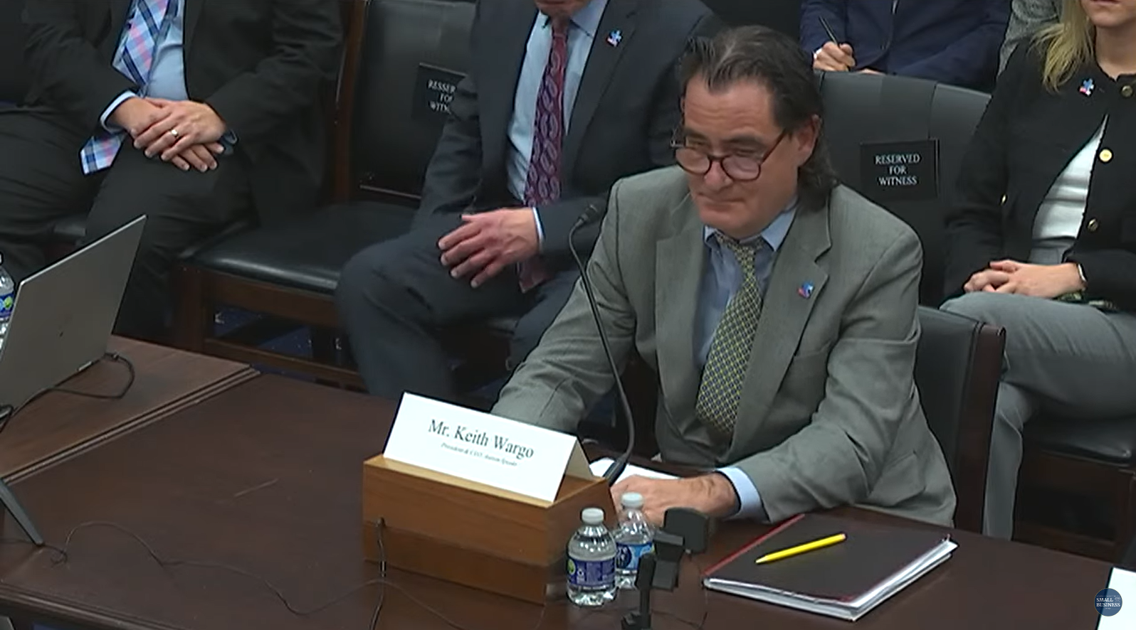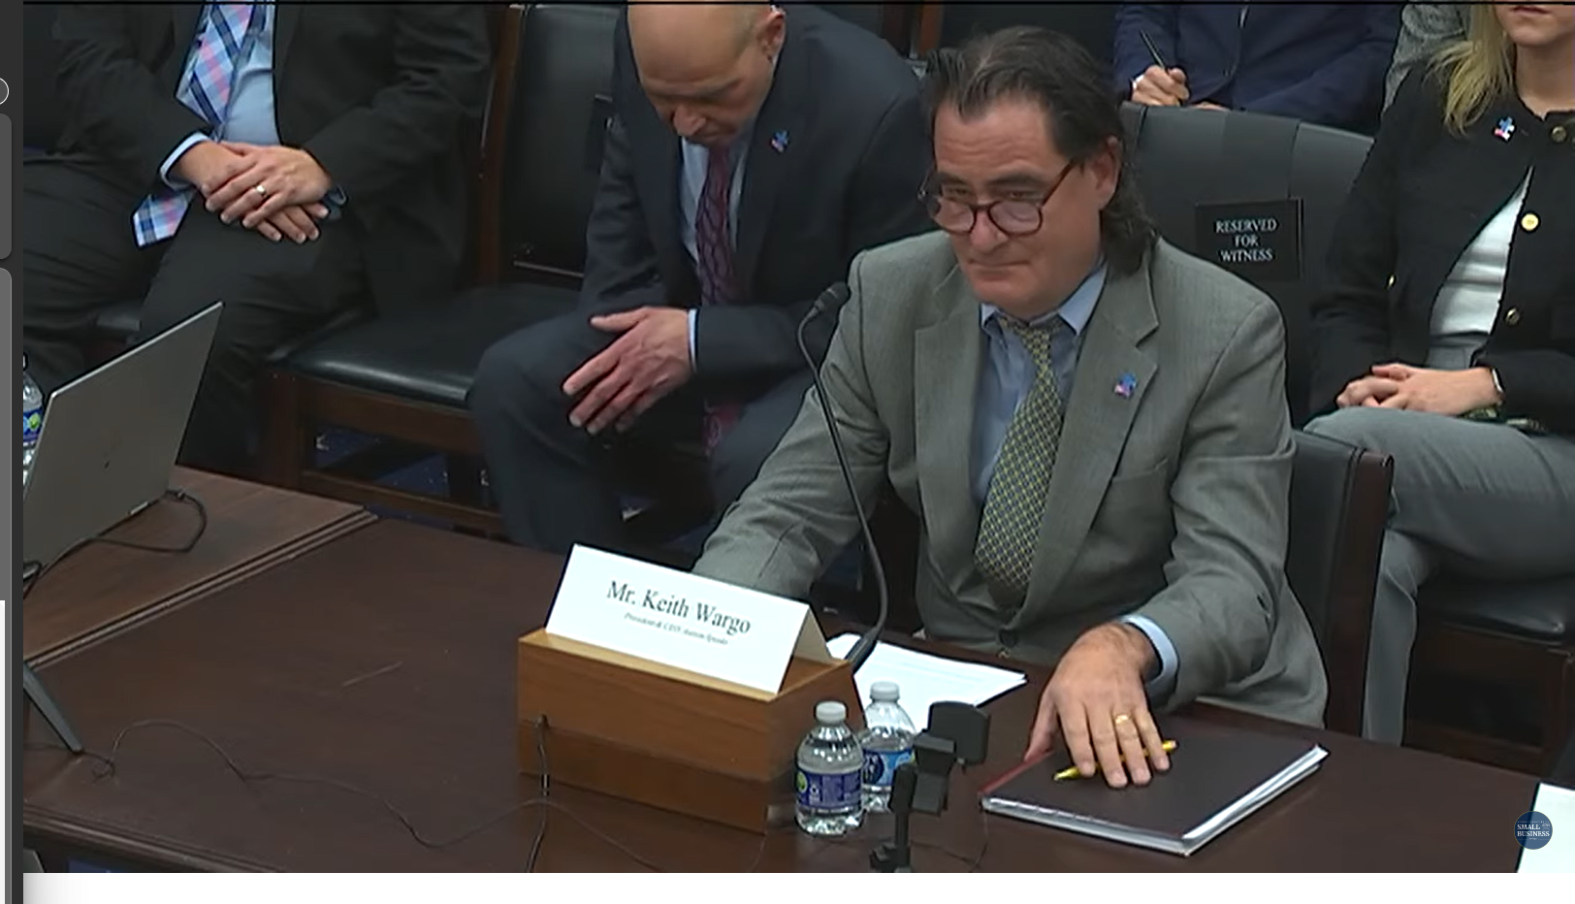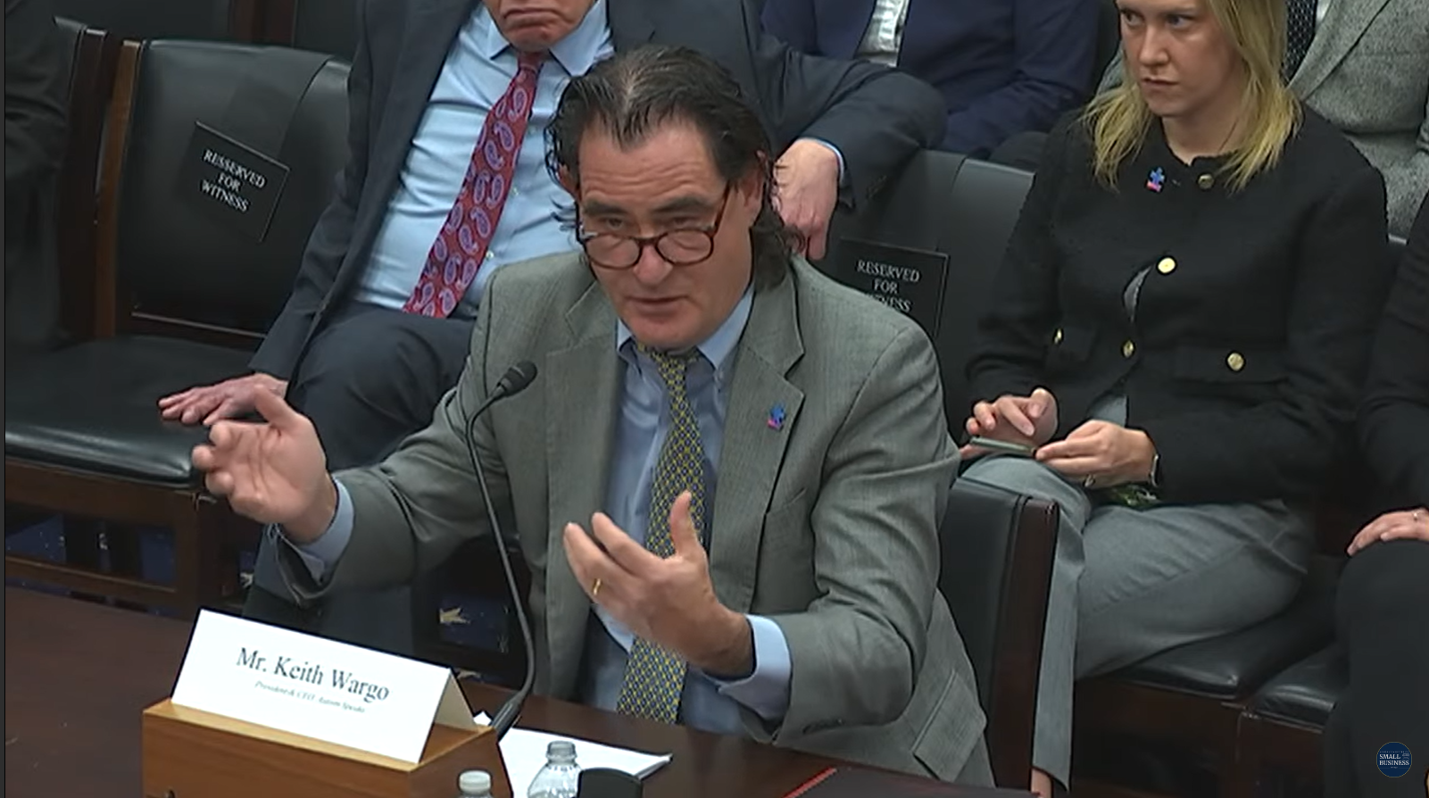

Keith Wargo – remarks (34:00)
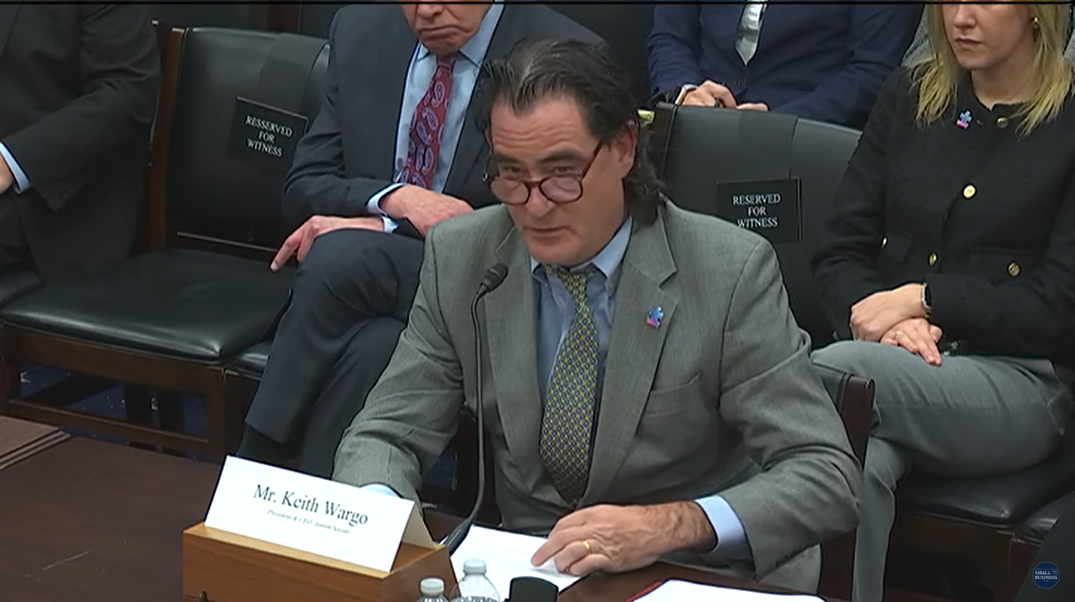

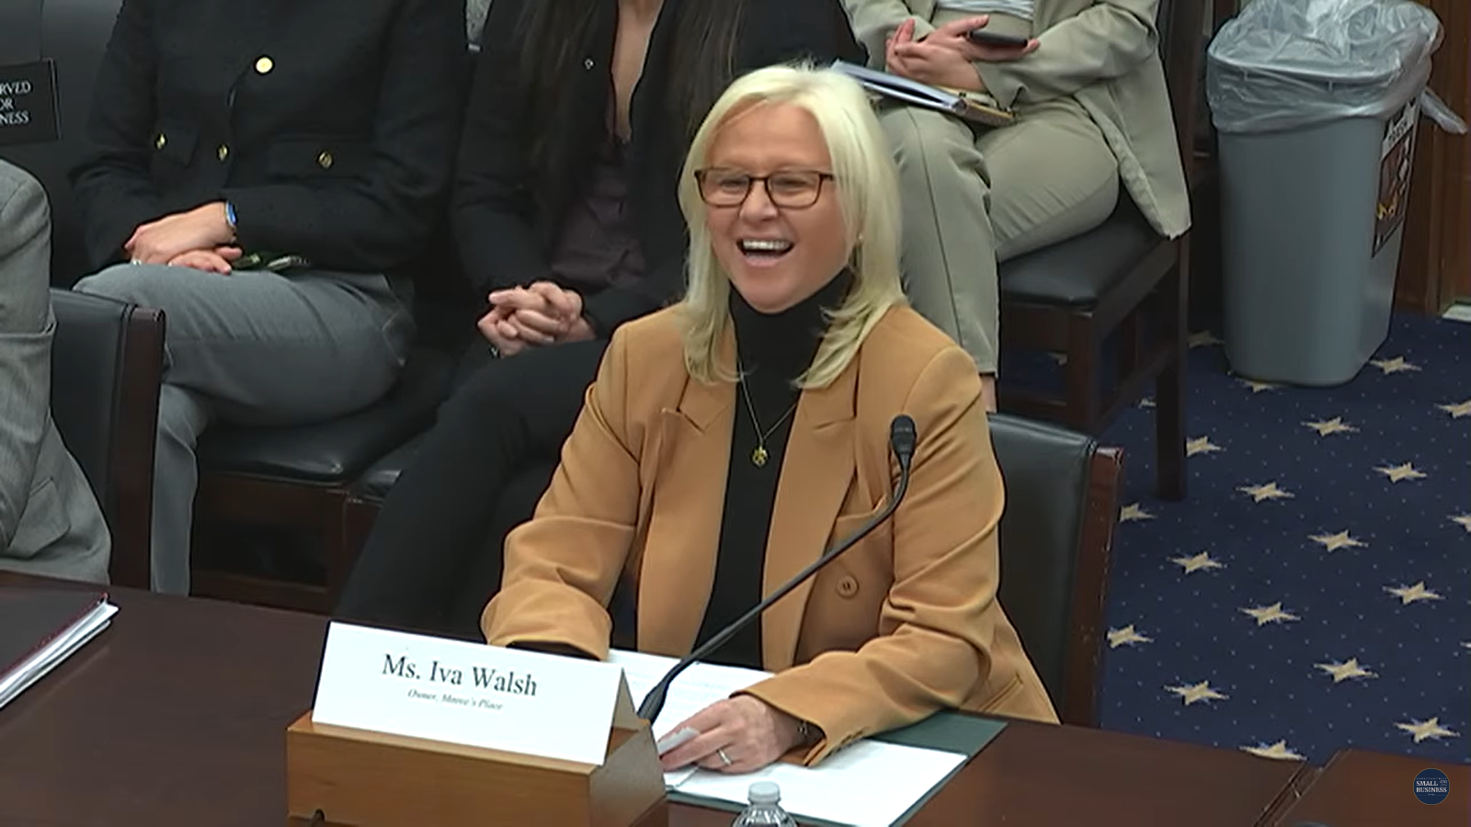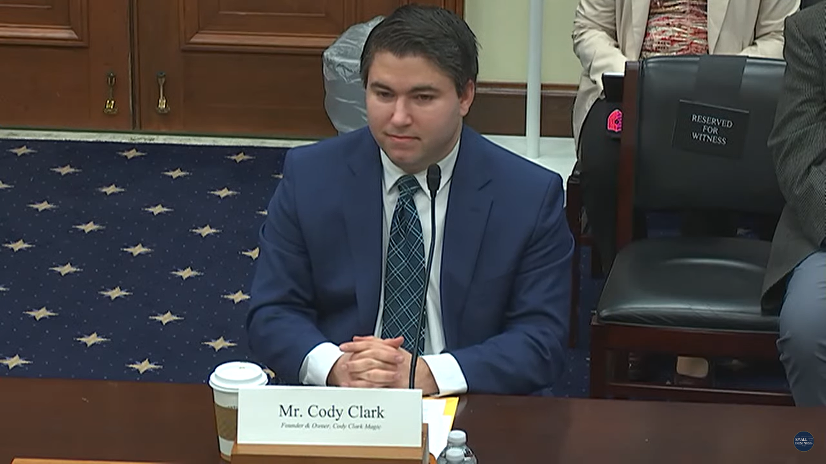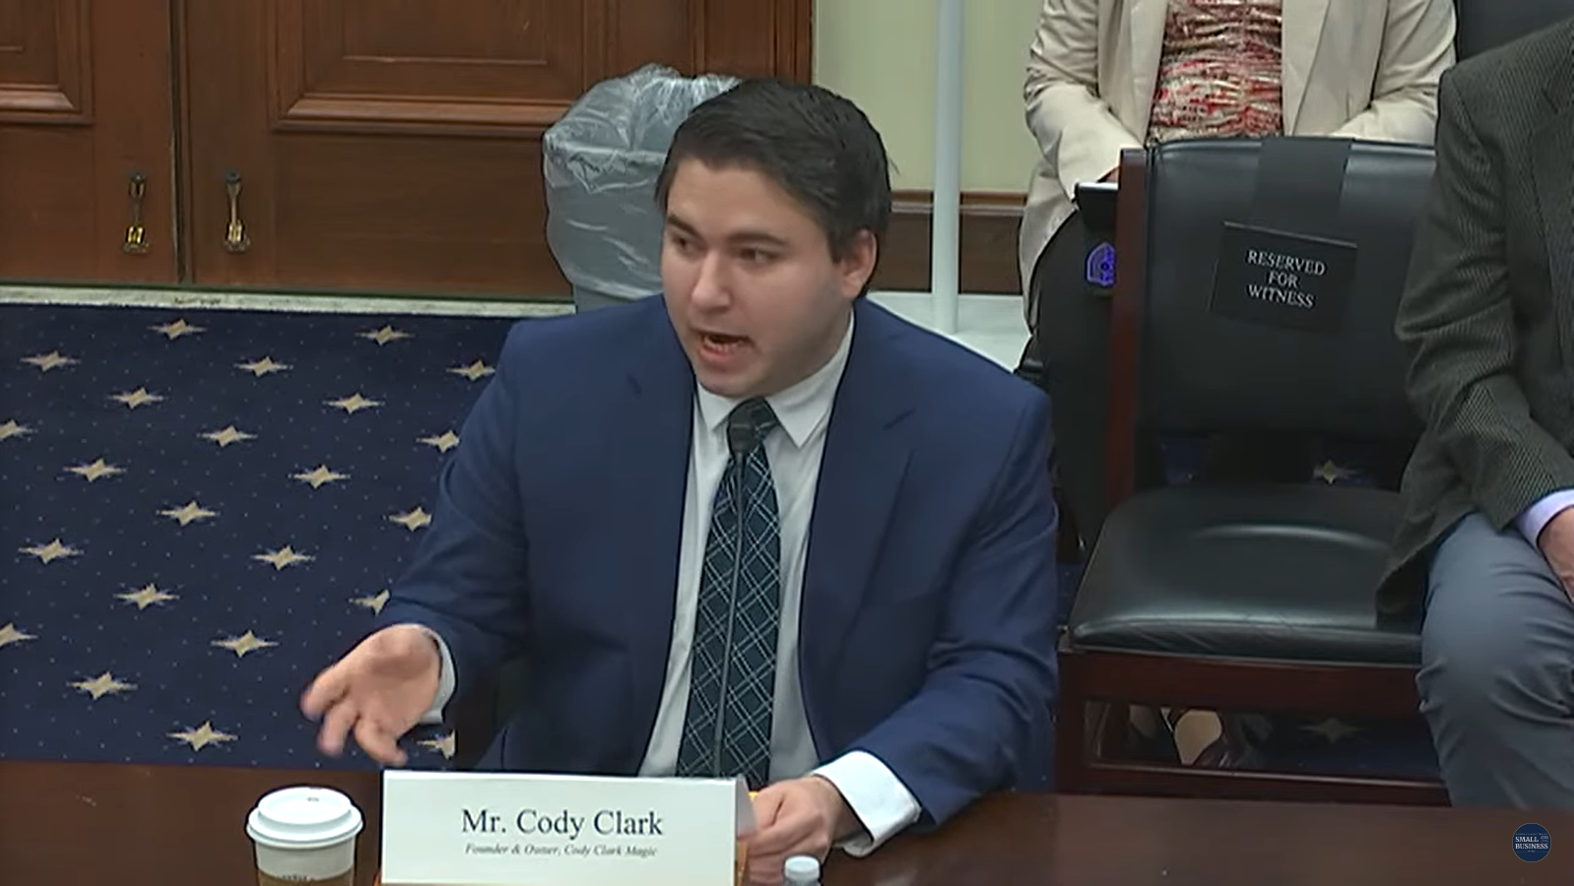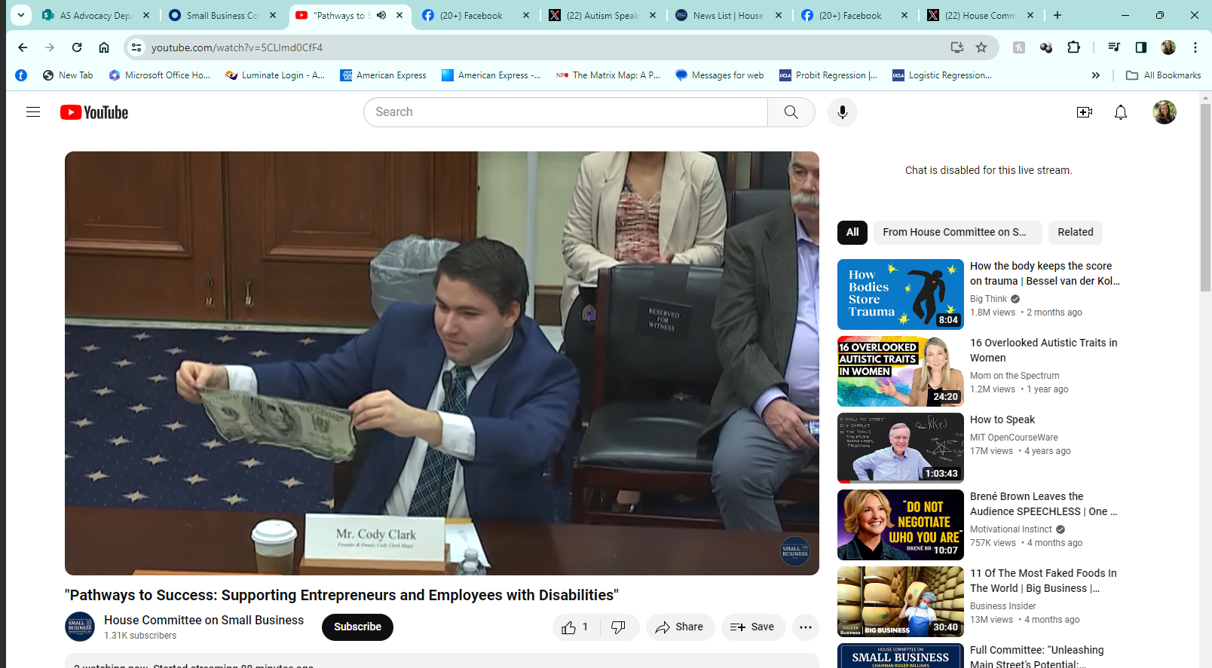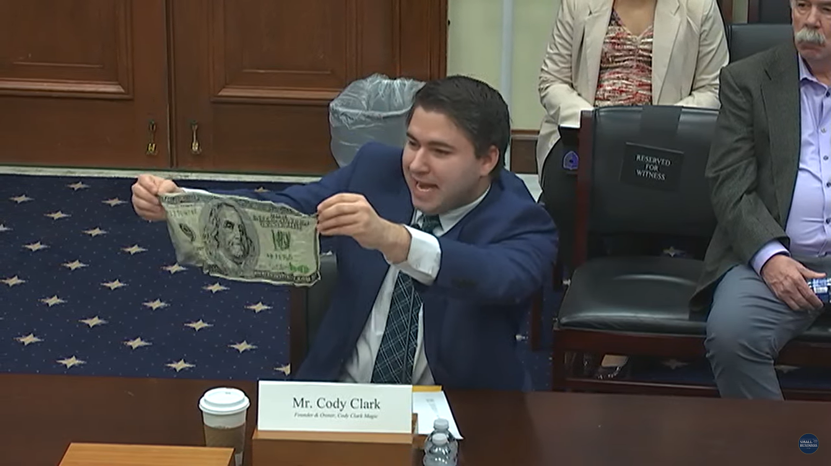

Bureau of Labor Statistics, Department of Labor, February 23, 2023.
Roux, Anne M., Shattuck, Paul T., Rast, Jessica E., Rava, Julianna A., and Anderson, Kristy A. National Autism Indicators Report: Transition into Young Adulthood. Philadelphia, PA: Life Course Outcomes Research Program, A.J. Drexel Autism Institute, Drexel University, 2015.
“Getting to Equal: The Disability Inclusion Advantage” Accenture, the American Association of People with Disabilities, Disability:IN, 2018.

