My Day at Home

7:00 am | 8:00 am | 9:00 am
10:00 am | 1111:00 am | 12:00 pm
1:00 pm | 2:00 pm | 3:00 pm
4:00 pm | 5:00 pm | 6:00 pm
7:00 pm | 8:00 pm

You can use this editable document to create a daily schedule. Drag and drop pictures to the time slot your family will use them, or copy and paste any activities that will be repeated during the day. Use only the time slots that you need to indicate the start of a new activity. You can also edit the time periods to any times that meet your needs. You can delete any extra columns or rows to make the schedule horizontal or vertical. Then, print out, and cut out if you wish, your at-home schedule to post where the whole family can see it for quick reference.

sleep

food

academic

creative/leisure

tasks

SQUARE VIEW

sleep
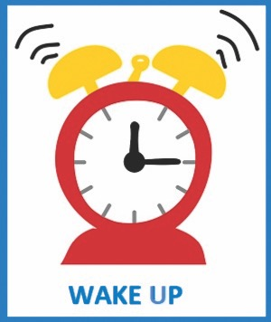
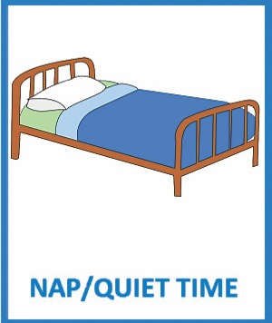

food

academic
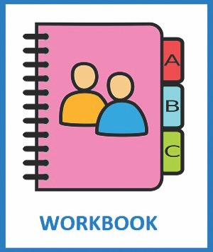

creative/leisure

tasks
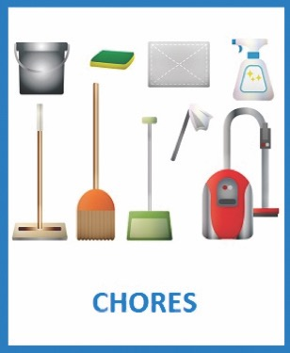

My Day at Home

7:00 am | 8:00 am | 9:00 am
10:00 am | 1111:00 am | 12:00 pm
1:00 pm | 2:00 pm | 3:00 pm
4:00 pm | 5:00 pm | 6:00 pm
7:00 pm | 8:00 pm | 9:00 pm

My Day at Home

7:00 am | 8:00 am | 9:00 am
10:00 am | 1111:00 am | 12:00 pm
1:00 pm | 2:00 pm | 3:00 pm
4:00 pm | 5:00 pm | 6:00 pm
7:00 pm | 8:00 pm | 9:00 pm

