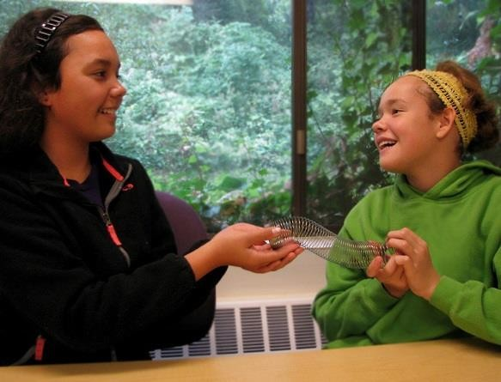

Taking Turns
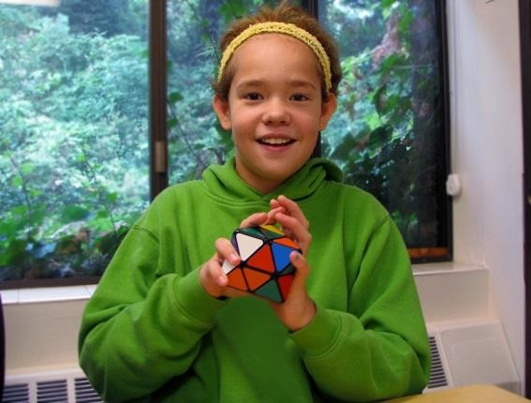I love playing with toys!
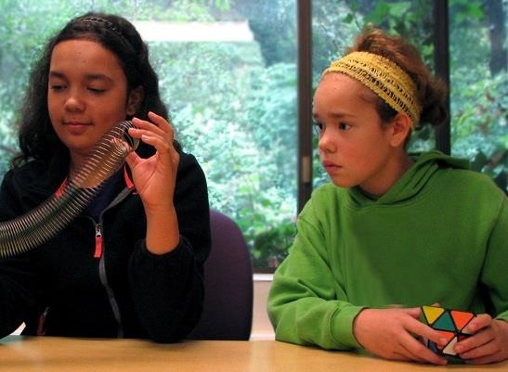Sometimes when I play with toys I want to grab a toy that someone else has.

This is not the best choice and can make us both unhappy.
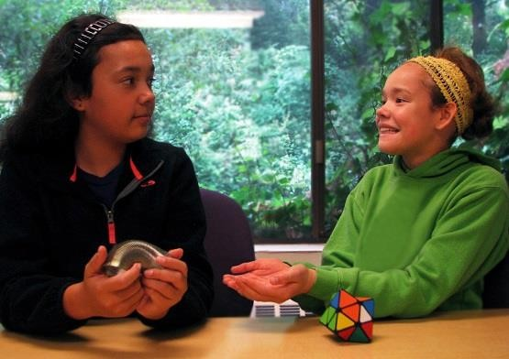I can ask for turns when I want a toy. I say, “Can I have a turn please?”
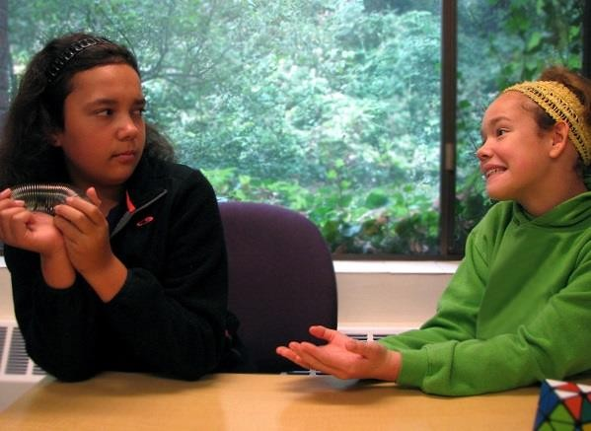Asking for a turn does not always mean I will get a
turn. That’s okay! I can make other choices.
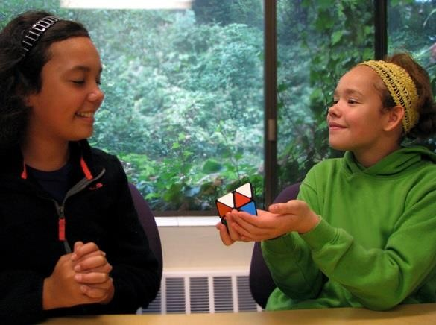I can offer to trade toys with my friend if I want what he/she is playing with.

If I really want to play with that toy, I need to make a good choice
about what to trade… something cool!
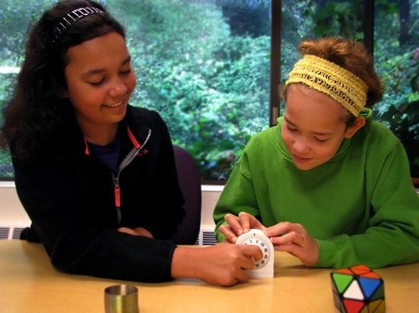We can try setting a timer so that we both have equal turns with the toy.
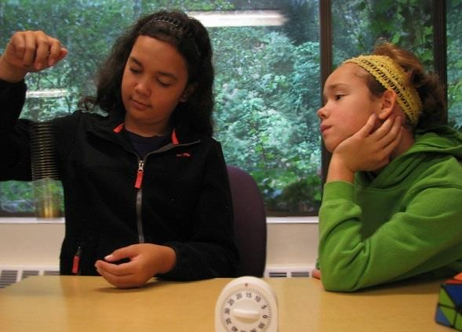I can ask my friend to tell me when he/she is done with the toy I want. I can make a new choice while I wait!
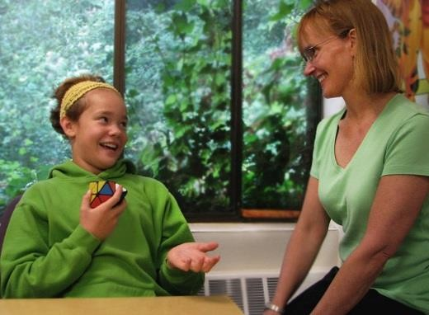If none of these choices works, I can ask an adult to help us take turns. Adults know all about how to take turns!
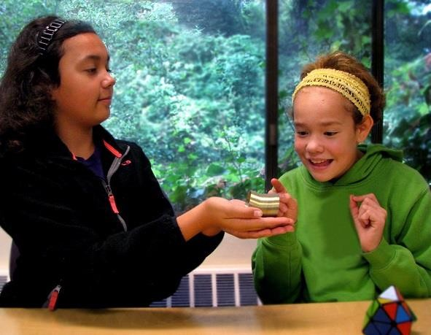I love playing with my friends and making good choices to help me take turns!

Things to Try

When I am having trouble taking turns or waiting for friend to give me a turn, I will:

• Ask for a turn

• Offer to trade

• Set a timer

• Make a new choice while waiting

• Ask an adult to help

• ….Please add your own ideas or modify the above

