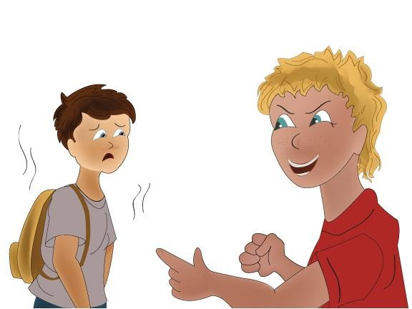

Handling Bullying
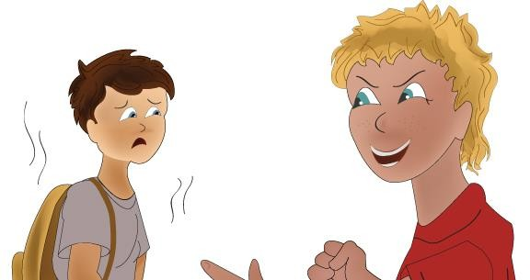Some children try to bully other children. Bullying can happen to anyone.
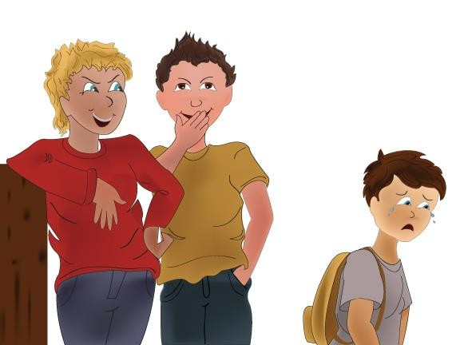Bullies may say mean things, call names, make fun of, tease, ignore or spread false rumors about others.
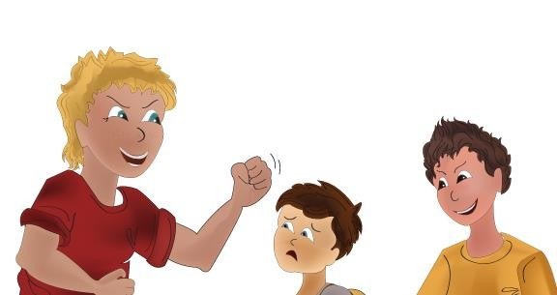Bullies may push, punch, shove, or take things from others.
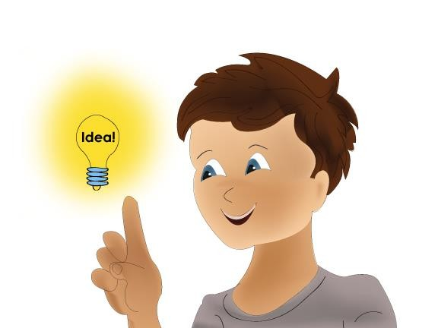Bullying usually happens when an adult is not around. I must learn how to recognize and handle bullies.
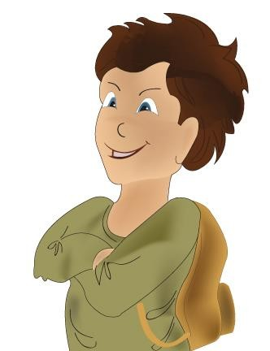To avoid getting bullied, I can walk with confidence, holding my head high, keeping a straight back and a calm face.

Bullies are more likely to pick on me if they think I am frightened.
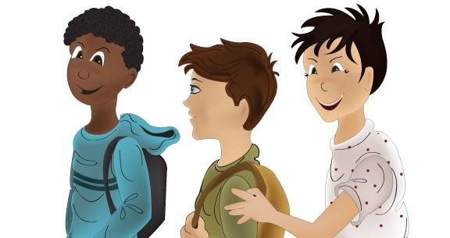Walk around the school with friends. Be kind and respectful toward other people. Bullies are less likely to approach when I walk around in a group and have lots of friends.
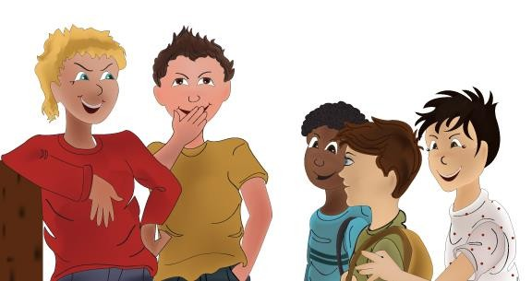Be aware of my surroundings. Try to avoid the bully by going somewhere else, always staying calm and confident.
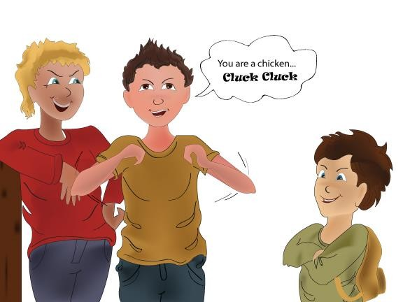I can ignore the bully. Bullies want me to act frightened or scared. A bully might continue talking. I don’t need to respond.
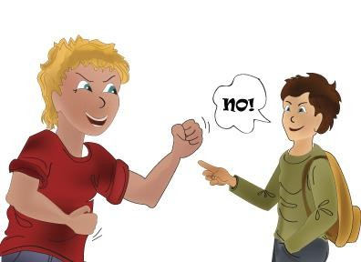If the bully continues to hurt me in any way, I can yell
“NO” using a firm voice so others can hear me.

I can also say “STOP! I DON’T LIKE THAT!”
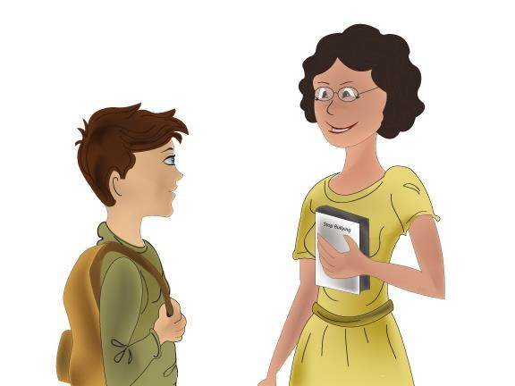I can go to a teacher or another adult for help.
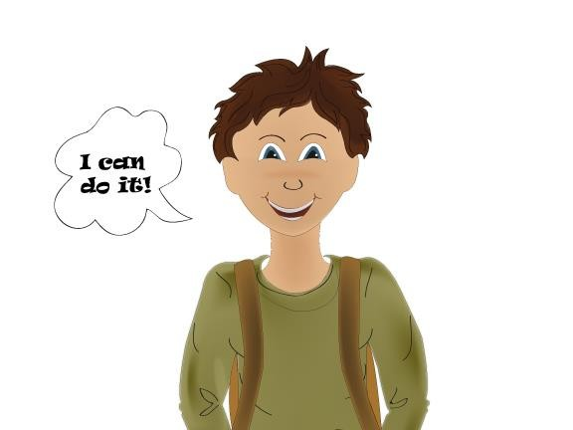Bullying will not stop unless I stand up against it. I need to make a plan and take action against bullying. I CAN DO IT!!!

Things to Try

Sometimes, I might see or hear about a friend being bullied. It feels good to help others. Here is what I can do to help a friend being bullied:

1. Go with my friend to a safer place.
2. Tell the bully to STOP!
3. Go with my friend to tell an adult.
4. Go on my own to tell an adult.

