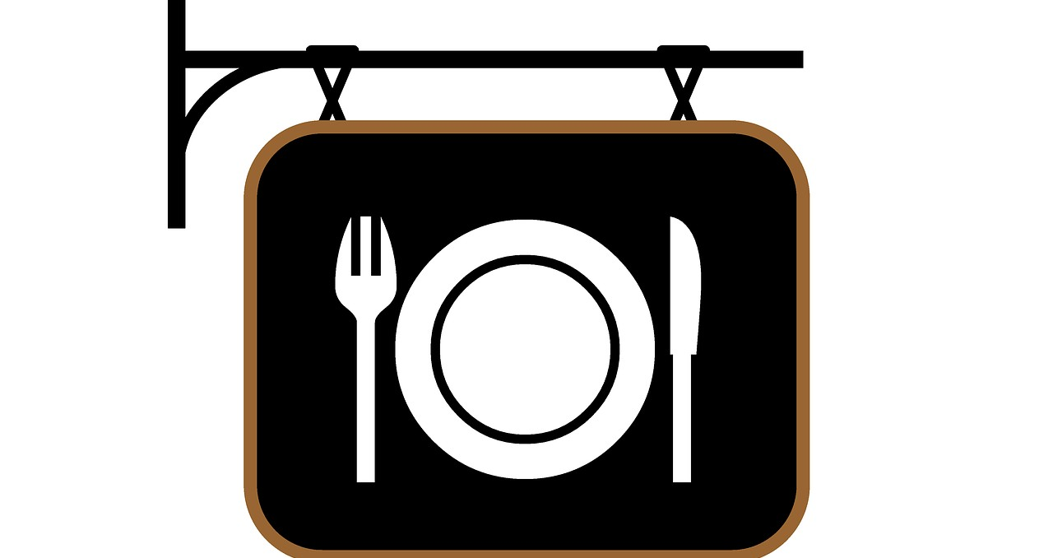

Going to a Restaurant
We are going to a restaurant. A restaurant is a place where people can go to eat food. Restaurants can be really fun!
Sometimes restaurants can feel noisy or crowded. It’s okay. I can tell my mom or dad if I feel scared or nervous.

They might hold my hand or take me for a short walk outside. I can take a break from the noise and
crowd and still have fun at the restaurant!
When we sit down at our table there might be a special menu for me to choose my food from.

Sometimes I may feel nervous about what I will eat, especially if the restaurant is new.

It’s okay! My mom and dad know what I like and will help me choose.
After we order our food I might have to wait again while they cook the food. This is okay too!

I can ask for crayons to color with or play tic-tac- toe.

I can also read books or listen to music again.
If someone talks to me while we are waiting for our food, it is a good idea to take a break from my book, music, or game to answer them.

Talking with people at restaurants is part of the fun!

I can return to my favorite activity after I answer.
When the food comes to the table, I should say
“thank you” to the person who brings the food.

If my food looks a little different than it does when I get it at home, it’s okay!

My mom or dad will help me feel good about the food because they know what I like!
I did it! Going to a restaurant was lots of fun and now
I know that I can do it again!

Things to Try

When we go to a restaurant, I can bring:

• A book

• A game

• …please add your own ideas or modify the above

