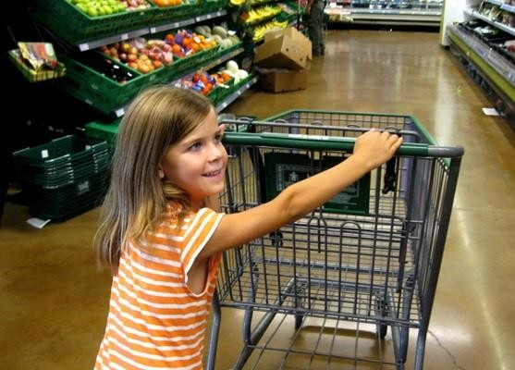

Going to the Store
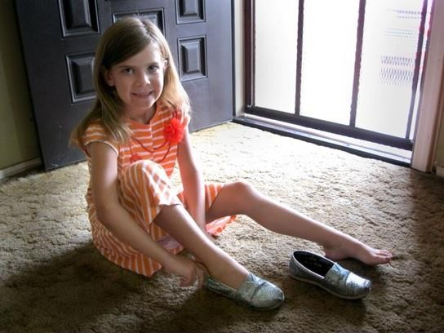It’s time to go to the store! I need to put on my shoes
and coat.
I will sit in the car and buckle my seatbelt, so I am safe.

Then Mom will get in the car, buckle her seatbelt, and off we go!
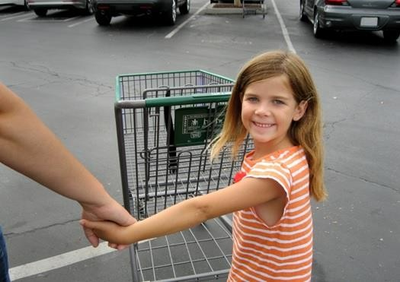When we get to the store, Mom will open my door, and I will get out of the car.

I will hold Mom’s hand in the parking lot so I am safe.
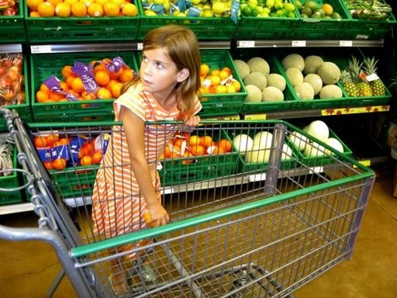I will walk next to Mom, and she will tell me what to put in the cart.

Mom said that I can only put things in the cart that she says are ok.
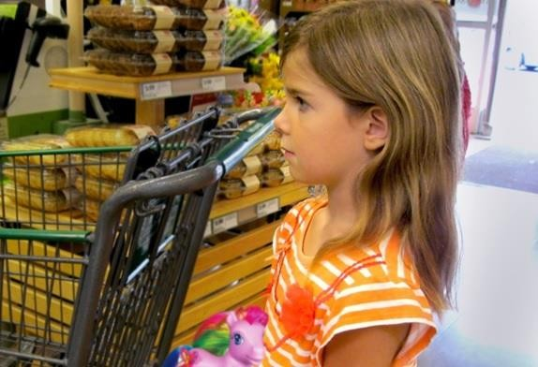Next we will go wait in line to pay. I can play with my toy while I wait.
It’s our turn! Mom puts the groceries we want to buy
on the counter.

The cashier rings up each item and puts it in the bag. Then the cashier puts the bags in the cart.
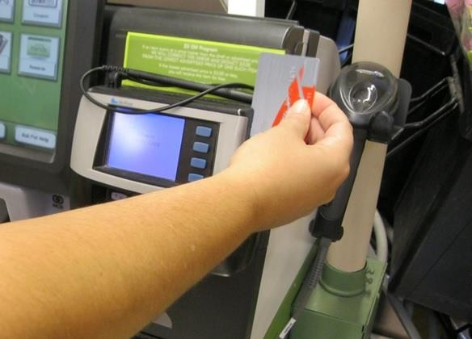Mom pays and says good bye.
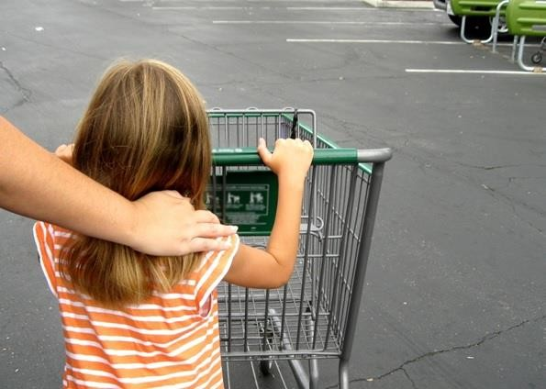I help my Mom push the cart back to our car.
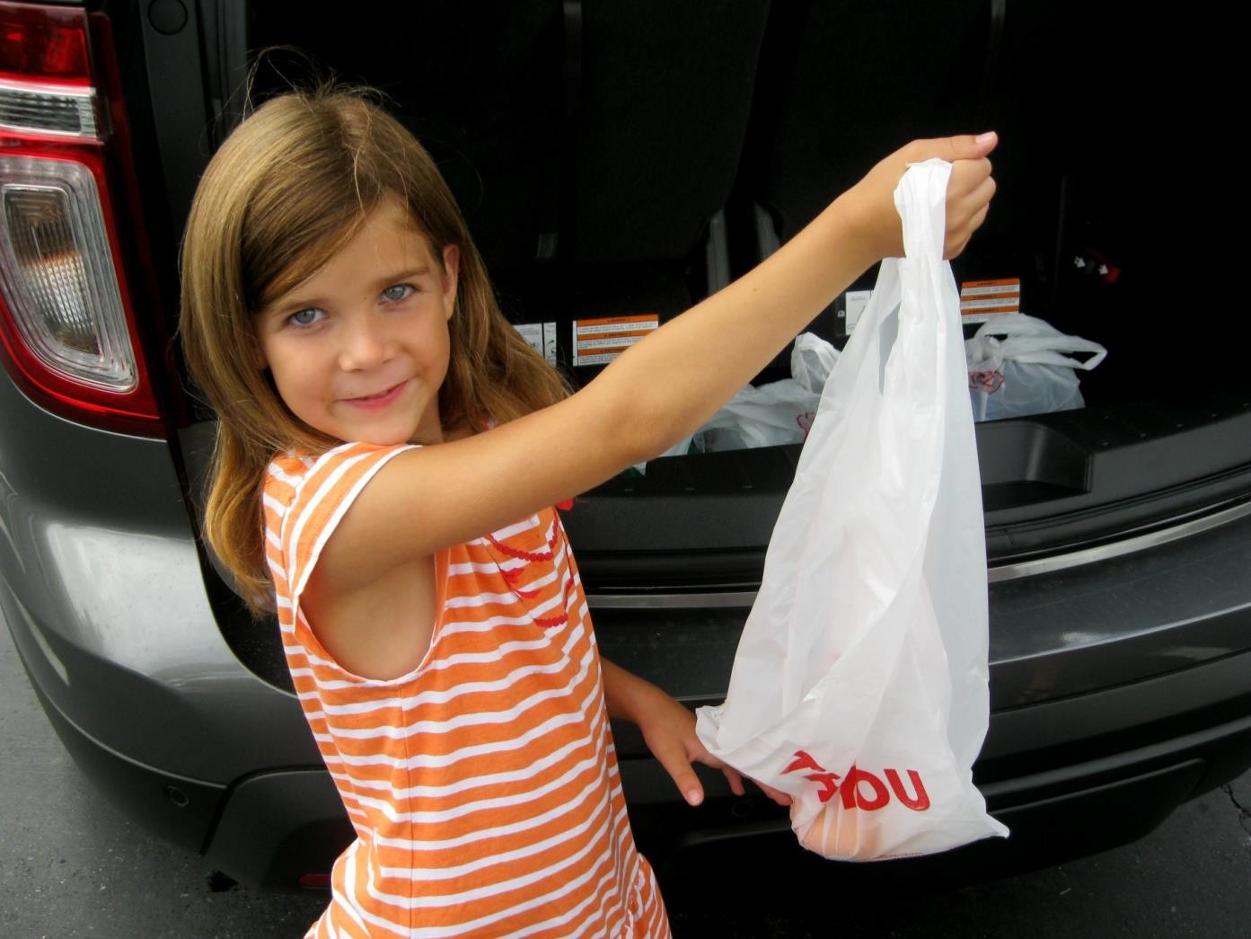I help my Mom puts the bags in the trunk.
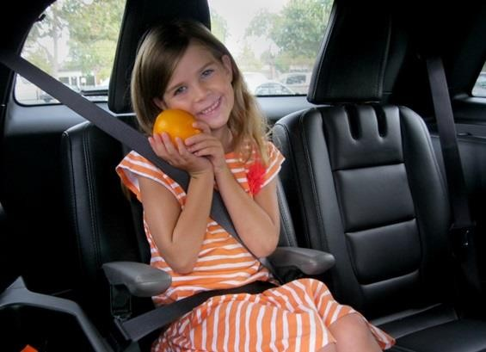I will get in the car and buckle my seatbelt. It’s time
to go home.

